Question 1 – Empirical Cumulative Distribution Function (ECDF)
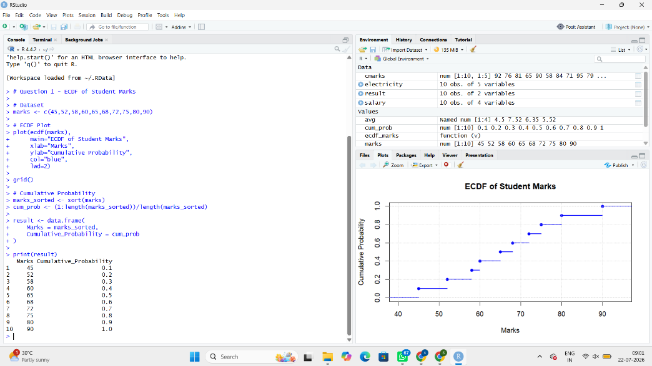
Question 2 – Empirical Cumulative Distribution Function (ECDF)
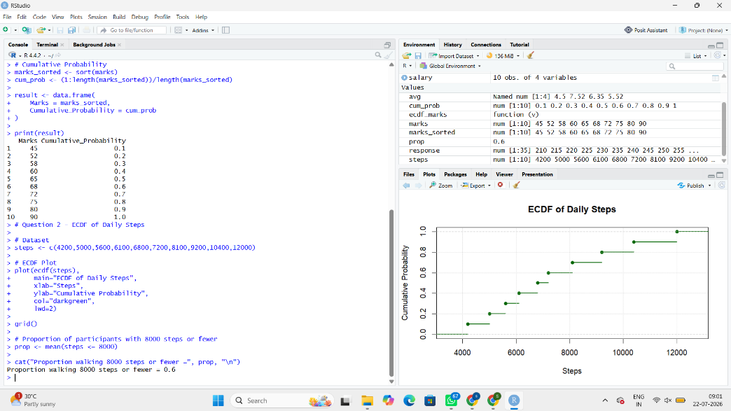
Question 3 – Highly Skewed Distribution (Histogram and Density Plot)
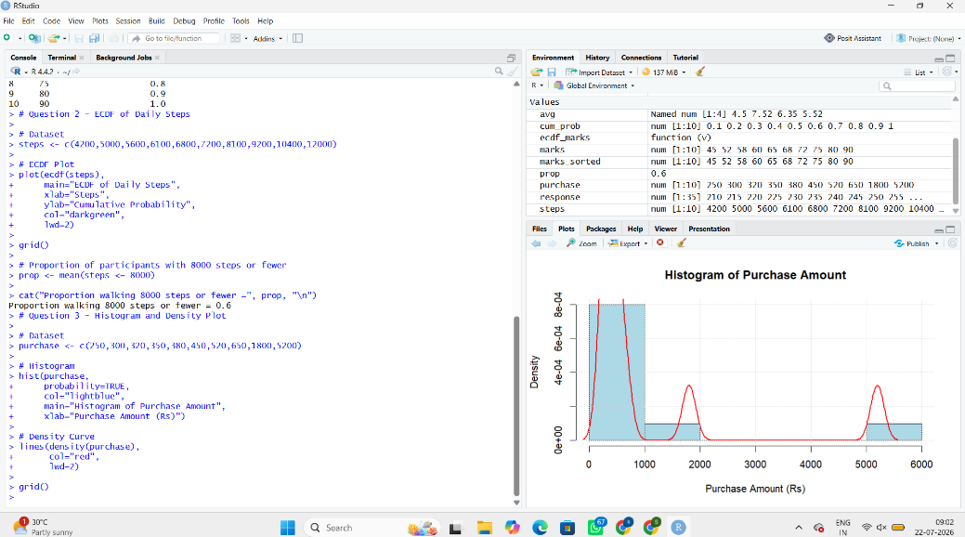

Question 4 – Quantile-Quantile (Q-Q) Plot
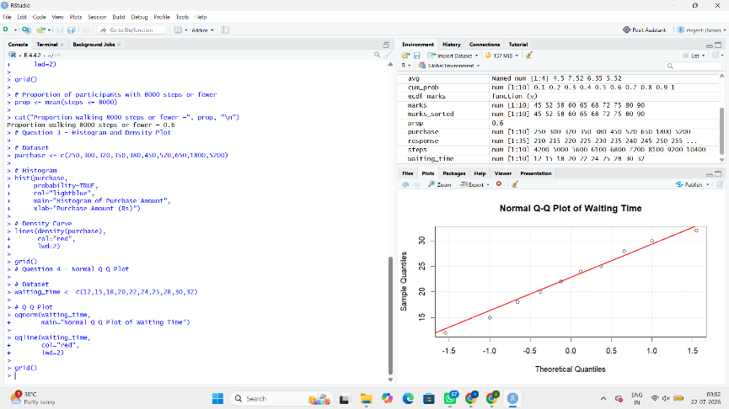
Question 5 – Highly Skewed Distribution and Q-Q Plot
